Low Level Design

Heart Disease Diagnostic – Analysis

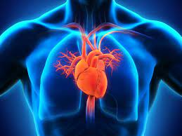

**DOCUMENT CONTROL**

|  |  |  |  |
| --- | --- | --- | --- |
| **VERSION** | **DATE** | **AUTHOR** | **COMMENTS** |
| 1.0 | 15/09/2022 | Sikha Pandey | Introduction and problem statement |
| 1.1 | 18/09/2022 | Sikha Pandey | Dataset information, Architecture Description |
|  | 20/09/2022 | Sikha Pandey | Final Revision |
|  |  |  |  |

**Contents**

## 1. Introduction……………………………………………………………………………………………………… 03

**1.1 What is Low-Level Design Document? ………………………………………………….. 03 1.2 Scope ………………………………………………………………………………………………………….…... 03**

## 2. Problem Statement ………………………………………………………………………… ……………… 04

## 3. Dataset Information ……………………………………………………………………………………… 04

**4. Architecture ……………………………………………………………………………………………….…… 05**

**4.1 Architecture Description …………………………………………………………………………… 05**

# 1. Introduction

**1.1 What is Low-Level design document?**

The goal of the LDD or Low-level design document (LLDD) is to give the internal logic design of the actual program code for the House Price Prediction dashboard. LDD describes the class diagrams with the methods and relations between classes and programs specs. It describes the modules so that the programmer can directly code the program from the document.

## 1.2 Scope

Low-level design (LLD) is a component-level design process that follows a step-by-step refinement process. The process can be used for designing data structures, required software architecture, source code, and ultimately, performance algorithms. Overall, the data organization may be defined during requirement analysis and then refined during data design work.

**1.3 Project Introduction**

Heart Disease is a type of disease that affect the heart or blood vessels. The risk of heart disease may increase by smoking, High Chol level, High Blood Pressure, and many other factors. Over the past few decades number of heart disease have increased rapidly and it has become a major concern in India. According to the World Health Organization, 28% of all deaths in India were related to Heart Disease. In 1990, 15% of deaths in India were due to heart disease.

Thus, preventing heart disease has become more than necessary. Good data can be helpful for predicting heart diseases and can improve the entire research and prevention process, making sure that they can adopt a healthy life.

**2. Problem Statement**

As the rate of Heart Disease is increasing rapidly and also in the pandemic we all realized the effect of covid-19 on all. We need to analyse health data for better future preparation. Taking a dataset that includes some of the information of some people.

**3. Dataset Information**

## There are thirteen features in Dataset

age: Age of the person

sex: Person's sex(1 = male, 0= female)

cp: Chest Pain. There are four types of pain chest pain(Angina).(1:Typical Angina, 2: Atypical Angina, 3: Non-anginal pain, 4: Asymptomatic)

tresttbps: resting blood pressure in mm Hg on admission to the hospital.

chol: Person's cholesterol level.

fbs: Person's fasting blood sugar level(1= True, 0= False)

restecg: Resting electrocardiogram.

thalach: It is a continuous data type that describes the max heart rate achieved.

exang: Exercise-induced angina(1= yes, 0 = No)

oldpeak: ST depression induced by exercise relative to rest.

Slope: The slope of the peak exercise ST segment(1: upsloping, 2: flat, 3: downsloping)

ca: number of major vessels (0-3) colored by fluoroscopy (for calcification of vessels).

thal: results of nuclear stress test (3 = normal; 6 = fixed defect; 7 = reversible defect).

num : target variable representing diagnosis of heart disease (angiographic disease

status) in any major vessel(0 = no, 1 = yes).

**4. Architecture**

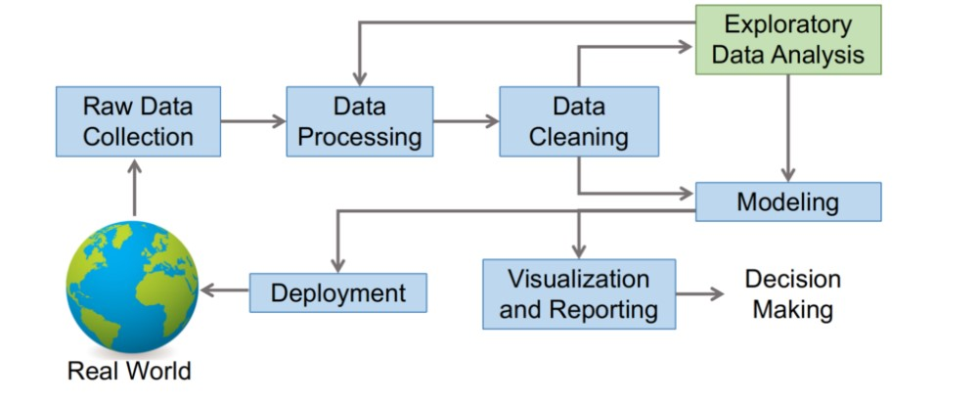

**4.1 Architecture Description**

**1. Raw Data Collection**

The dataset was provided in iNeuron’s Project Description Document.

https://drive.google.com/drive/folders/165Pjmfb9W9PGy0rZjHEA22LW0Lt3Y-

Q8?usp=sharing

**2. Data Processing**

The first step is to process the data to feed the correct data to the model to learn and predict. The outcome will be dependent on the type of raw data feed.

This process includes:-

1. Handling missing /null values
2. Handling noisy data
3. Detecting Outliers and Removing them

**3. Data Cleaning**

Data cleaning is the process of detecting and correcting corrupt or inaccurate records from data-set and refers to identifying incomplete, incorrect, inaccurate, or irrelevant parts of the data and then replacing, modifying, or deleting the dirty or coarse data

**4. Exploratory Data Analysis (EDA)**

Exploratory Data Analysis refers to the critical process of performing initial investigations on data so as to discover patterns, spot anomalies, test hypotheses, and check assumptions with the help of summary statistics and graphical representation.

**5. Reporting**

Reporting is the most important and underrated skill of the data analytics field.

Because our data report can answer basic questions about the state of the business.

1. High-Level Design Document (HLD)
2. Low-Level Design Document (LLD)
3. Architecture
4. Wireframe
5. Detailed Project Report
6. Power Point Presentation

**6. Modelling**

Data modeling is the process of diagramming data flows. When creating a new or alternate database structure, the designer starts with a diagram of how data will flow into and out of the database.

**7. Deployment**

We created a Power BI Dashboard.

